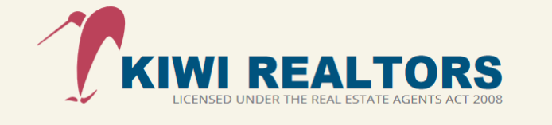

KIWI REALTORS IN HOUSE COMPLIANTS AND DISPUTE RESOLUTION PROCEDURES
STEP 1
Call to speak to the Administrator/Principal Agent (Mike Er)
Office Telephone No :09-3918818 or Email Mike Er mikeer.nzrcr@orcon .net.nz
Office Address: Unit T, 162 Mokoia Road, Chatswood, North Shore, Auckland 0626

Step 2
Principal agent/manager may request you to lodge the complaint in writing. Should we request you to put the complaint in writing please allow 10 working days for us to respond. The principal agent /manager may require a brief period to the team members and come back to you with a response

Step 3
As part of the response, we may request you to meet with the members of our team to discuss the issue and come up with a resolution. If there is no consensus reached, after the meeting. Or if you do not wish to meet us, then we will provide you a written proposal to resolve the complaint.

Step 4
If you do not accept our proposal, please try and advise us in writing within five working days. You can of course suggest another way of resolving your complaint. If we accept your preferred resolution, we will endeavour to implement as soon as possible. If we decline your preferred resolution, we may invite you to mediate the dispute.

Step 5
If we agree to mediate the complaint but do not settle the complaint at mediation, or we do not agree to mediate the dispute, then that will be the end of our process

Remember you can still make a complaint to the Real Estate Agents Authority in the first instance and, even if you use these procedures.
The Real Estate Agents Authority C/O PO BOX 25-371 WELLINGTON 6146, NZ Phone 0800-367 7322

